This FREE LESSON introduces the potential of body wisdom to transform adversarial thinking in arguments and disputes. See YouTube video Mission of Somatics, by Richard Strozzi-Heckler. The ten-lesson online course teaches how the body enables us to identify our predisposed responses to pressure and transform them with embodied compassionate communication. What is the connection of Non-Violent Communication (NVC) and Emotional Aikido? Answering this question begins by understanding that NVC is a language skill and does not encompass somatic training. Somatic attunement, however, can be put into words, and may result in expressing the fundamental concepts of NVC, but they by very different paths; one is embodied, the other is in-minded. Click here for full discussion.

PART ONE. Identify (reaction patterns)
- Imagine pressure situation.
- A feel a tension/reaction in your body.
- Name your reaction.
- Push back
- Cave in
- Rigidify
- Other
PART TWO. Locate the ache. (in your HEAD, HEART, or HARA)
- Where in your body do you feel this situation is grabbing you? Does it give you a headache? Stiff neck? Heart ache? Belly ache? I’m asking just where not how intense or subtle.
- For you with headaches, notice distinctions, judgments, stories. For you stiff necks and heartaches, notice unexpressed feelings in self and others. For you with bellyaches, consider what unmet needs and unfulfilled expectations abound.
PART THREE. Center and ground.
- For headaches and stiff necks, drop attention into breathing. Breathe into the tension, and focus on flowing in attention and flowing tensions out.
- For heartaches, breathe into solar plexus in between heart and belly. Feel this horizontal division as both a separation, increasing awareness of uniqueness, and as unity. Focus on breath flowing down and up.
- For belly aches, feel body weight in pelvis, legs and feet. Focus on breath/energy flowing into the earth and back into your belly.
PART FOUR. Moving: where the action is.
While standing, step back and drop your weight down slightly from center.
- If you stepped back past center, adjust forward seeking center, shifting around it incrementally less and less, had you identified caving as a recognized predisposition?
- If you adjusted to find center by moving further back and then shifting around, had you observed any pushing back in your predisposition?
- If you felt unbalanced in any form, drop your attention into your weight. Its center-point is connected with the planet’s core. Sensing body-weight in space(kinesthetic/balance) is listening to gravity as though it speaks to you. We listen. In our inner-ear.

Step forward on the same side and repeat, at least until you notice improvement finding center, then switch sides. This is a basic practice, and you will benefit mostly by doing it often, even in a split second when it fits into the getting-up-and going.
PART FIVE. Transform the Pressure
Imagine holding a mood or attitude associated with your pressure situation in your hands in front of you. Feel its weight, and feel the weight of your body. When you are ready to let it go, release it completely, into and through your own body weight, leaving your hands open to feel and receive something that returns as when dropping a ball initiates a “bouncing back.” Notice its quality in your hands and arms as they receive the new sensations.
Name the mood or attitude you associate with the new sensations, and repeat the exercise as often as you wish. When you are ready to extend your practice into a new situation, let he quality/energy fill your body, expanding out in front of you, behind and above you. Let it move in your breath and arms. Extend this expanding energy into your next situation without giving up your ground or losing your balance.

P.S.
As a more advanced form of practice, ask a friend to repeat the pressure statement while adding enough physical pressure to your sternum to test the predisposed push-back, cave-in or rigid response. Practice feeling increasing depth of connection with Earth’s core when you settle and deepen in order to receive the combined verbal and physical pressure.

You can learn to practice grounding and centering in movement (which is how it comes at us in life) by studying the online course or taking an Emotional Aikido clinic or private session with me in Sebastopol.

“Aikido is a way to reconcile the world.” Morihei Ueshiba

This embodied communication lesson was written by Jerry Green,
creator of the ten lesson online course, TUNING IN to the Body
© Copyright 2013 by Jerry Green
Available now at http://GreenerMediations.net/embodied,
at a special promotional discount.

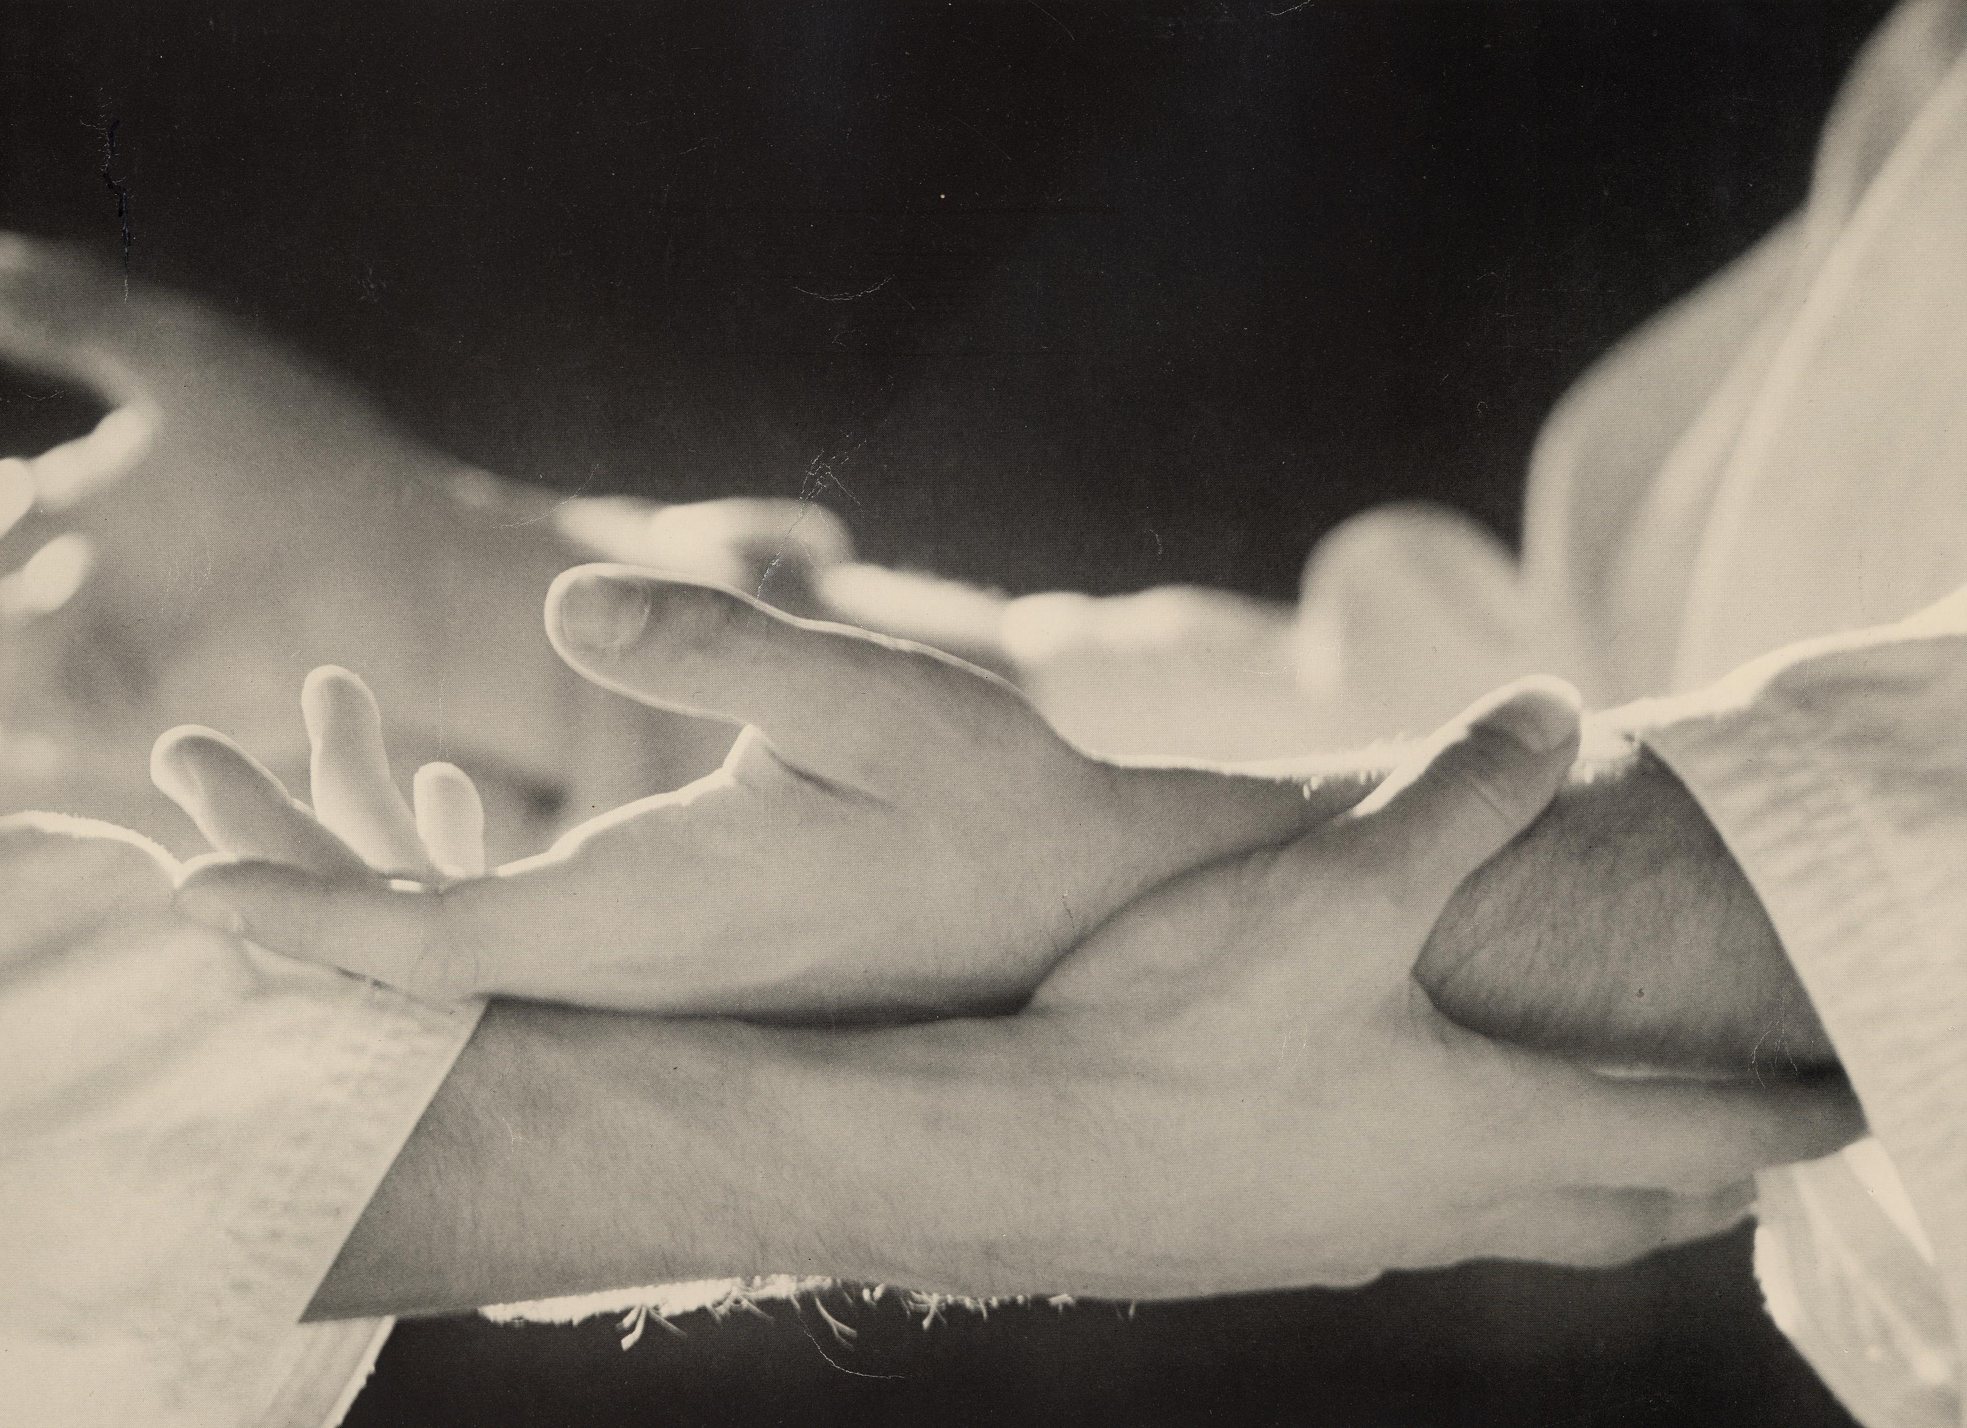
www.GreenerMediations.net/Embodied
(Jan Watson photo)

Course Overview: by Jerry Green

This course applies these principles to the challenges that we all face in personal relationships at work and at home. Relationships involve conflicts. This series of lessons combines principles of conflict resolution, somatic awareness training and Aikido, the marital art of peace.

After learning the basics elements of body-wisdom, you will learn your body’s predispositions for responding to verbal pressure, and identify their relationship to how your mind thinks when engaged in word-wars. There’s physical pressure and then there’s verbal pressure. Because they are closely linked, we are studying mediation
and Aikido together.

The central lessons teach grounding and centering in the body, finding its core and learning to engage with physical pressure in a confident and relaxed manner. The final lessons reestablish the mental connections by putting words to newfound body wisdom. You will learn to speak your body-wisdom, which will enables you to transform adversity in arguments and disputes into understanding, connection and collaboration.

It is unnecessary to pre-think solutions to a real conflict.
Identifying and transforming our predisposition allows alternatives to emerge in a manner that is more timely and appropriate than predetermined strategies.

Blending
without losing integrity,
is an attitude, not a technique.

TUNING IN to the Body
The online course in Emotional Aikido by Jerry Green
Including Aikido Walking with George Leonard
Introduction by Wendy Palmer

INTRODUCTION: Conscious Embodiment,
by Wendy Palmer
LESSON ONE
The body-wisdom basics.
LESSON TWO
Predisposed responses to pressures.
LESSON THREE
ROTATIONS: Body wisdom basics in motion.
LESSON FOUR
GROUND AND CENTER: Hara and gravity.
LESSON FIVE
RELEASING: The preparation for learning extension.
LESSON SIX
EXTENSION
LESSON SEVEN
ENGAGEMENT
LESSON EIGHT
Reverse body language.
LESSON NINE
Applications and practice.
LESSON TEN
Aiki-dance: Two step fun & games.
AIKIDO WALKING
by George Leonard

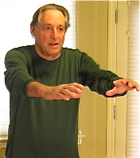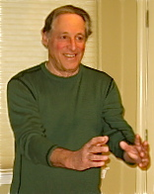
Before the course. After the course.

Friend, our closeness is this:
Anywhere you put your foot
Feel me in the firmness under you.
Rumi

